

CONTACT:
Anne Marie McLaughlin
amclaughlin@tennisfame.com
Office: 401-324-6033
Cell: 401-626-7615

Spanish tennis great Manuel Orantes to be inducted to the International Tennis Hall of Fame

- Orantes, the 1975 US Open champion and former world No. 2, is the only 2012 inductee in the Master Player Category. He joins tennis administrator Mike Davies and wheelchair tennis star Randy Snow, who were previously announced, as members of Class of 2012. The remainder of the Class of 2012 will be announced within the month ahead. The Induction Ceremony will be July 14, 2012 in Newport, R.I. –

NEWPORT, R.I., USA, February 23, 2012 — Manuel Orantes, a Spanish tennis star of the 1970s and 1980s, who defeated top top-seeded Jimmy Connors to capture the 1975 US Open title and played an instrumental role in Spain’s Davis Cup efforts for many years, will be inducted to the International Tennis Hall of Fame this year. Orantes is the third member of the Class of 2012 to be announced, and he is the only inductee in the Master Player Category. It was previously announced that tennis administrator and promoter Mike Davies has been elected in the Contributor Category and that Randy Snow has been elected in the Recent Player Category for his great achievements as a wheelchair tennis player. Additional members of the Class of 2012 will be announced within the month ahead. The Induction Ceremony will be hosted on July 14 at the International Tennis Hall of Fame & Museum in Newport, R.I.

"Manuel Orantes’ 1975 US Open victory is in the books as one of the most impressive in tennis history,” said Tony Trabert, 1970 Hall of Famer and Chair of the Enshrinee Nominating Committee. “That achievement, as well as his many other victories, and his leadership as a dedicated Davis Cup player for Spain make him a true legend of tennis. He is well deserving of induction to the International Tennis Hall of Fame and we look forward to celebrating with Manuel at the induction ceremony in July, along with honoring the additional inductees, the remainder of whom will be announced shortly.”

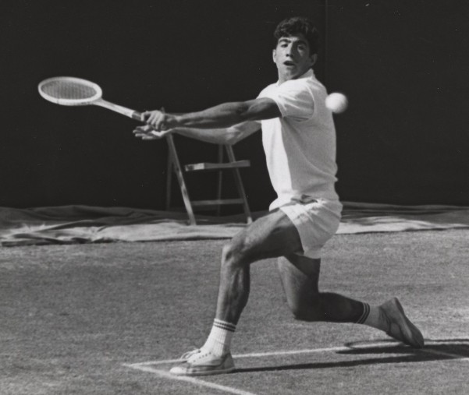
Orantes, 62, who is originally from Granada and now resides in Barcelona, reached the world No. 2 ranking in 1973, and he remained in the year-end world top-10 for five consecutive years. In addition to his notable US Open victory over Connors, he was runner up to Bjorn Borg at the 1974 French Open. In all, Orantes won 33 singles titles, and compiled an impressive record of 647-247. He has a career doubles record of 298-155 and won 22 titles.

Orantes was an integral member of the Spanish Davis Cup team from 1967-1980. In his first year playing, 1967, the team advanced to the final, falling to the Australians. In Davis Cup records, Orantes is tied for the most number of years played (14) with Sergio Casal and Manuel Santana. Orantes' Davis Cup career resulted in 60 wins and 27 losses, including 39 singles victories. In 2009, Orantes was presented the Davis Cup Award of Excellence by the International Tennis Hall of Fame and the International Tennis Federation. He was also a member of the victorious Spanish team that won the 1978 World Team Cup.

Located in Newport, Rhode Island, the International Tennis Hall of Fame & Museum is a non-profit organization dedicated to preserving the history of tennis and honoring its greatest champions and contributors. Induction to the International Tennis Hall of Fame is based on the sum of one’s achievements and accomplishments in tennis and is the highest honor a player or leader in the sport can receive. Since 1955, the International Tennis Hall of Fame has inducted 220 people from 19 countries. Orantes is the fifth Spanish inductee to the International Tennis Hall of Fame. The other Spanish legends who have been inducted are Manuel Alonso, Andrés Gimeno, Arantxa Sánchez -Vicario, and Manuel Santana.

Eligibility & Voting

Inductees to the International Tennis Hall of Fame are elected in the categories of Recent Player, Master Player and Contributor.

Orantes has been elected to the Hall of Fame in the Master Player Category. Eligibility criteria for this category is as follows: competitors in the sport who have been retired for at least 20 years prior to consideration; a distinguished record of competitive achievement at the highest international level, with consideration given to integrity, sportsmanship, and character.

The International Masters Panel, which consists of Hall of Fame inductees and individuals who are highly knowledgeable of the sport and its history, votes on the Master Player. To be inducted in any category, an affirmative vote of 75% is required.

Induction Ceremony

The Class of 2012 Induction Ceremony will be hosted on July 14 at the International Tennis Hall of Fame & Museum in Newport, R.I. The ceremony is held in conjunction with the Campbell's Hall of Fame Tennis Championships, an ATP World Tour event. Tickets for that day include seats for the Induction Ceremony and the tournament semi-finals, and tickets are available now on tennisfame.com or by phone at 866-914-FAME (2363).

###

About the International Tennis Hall of Fame & Museum
Established in 1954, the International Tennis Hall of Fame & Museum is a non-profit institution dedicated to preserving the history of tennis, inspiring and encouraging junior tennis development, providing a landmark for tennis enthusiasts worldwide, and enshrining tennis heroes and heroines with the highest honor in the sport of tennis- induction into the International Tennis Hall of Fame. In 1986, the International Tennis Federation, the governing body of tennis, officially recognized the International Tennis Hall of Fame & Museum as the sport's official Hall of Fame. The Hall of Fame is located in Newport, Rhode Island, USA, on a six-acre property that features an extensive Museum chronicling the history of the sport and honoring the 220 Hall of Famers; 13 grass tennis courts and an indoor tennis facility that are open to the public and to a club membership; a rare Court Tennis facility; and an historic 297-seat theatre. Annually in July, the venue hosts the Campbell's Hall of Fame Tennis Championships for the Van Alen Cup, an ATP World Tour event. The buildings and grounds, which were constructed in 1880 by McKim, Mead & White to serve as a social club for Newport's summer residents, are renowned for their incredible architecture and preservation. The facility was designated a National Historic Landmark in 1987. The International Tennis Hall of Fame & Museum is supported by Official Partners including BNP Paribas, Campbell Soup Company, Chubb Personal Insurance, Kia Motors and Rolex Watch USA. For information on the International Tennis Hall of Fame & Museum and its programs, call 401-849-3990 or visit us online at www.tennisfame.com.

